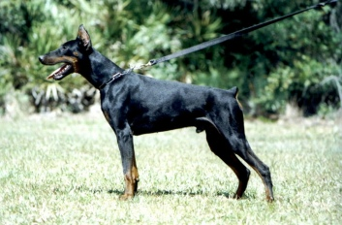
Tell v. d. Kusthoeve

Tell van de Kusthoeve, IPO 3 (high scores: 97/95/96), '99 Belgian National Working Dog Championship for Dobermanns - 5th. Pl., SDA PD K-9 Cert., HD-1, Thyroid-Normal, Full Dentition.
Tell v. d. Kusthoeve was imported, owned & handled by Linda M. Werlein (”von Asgard” Working Dog Kennels). Tell is a Belgian import that is linebred: Bingo v. Ellendonk, Nicolai v. Kloster Kamp, Goliath v. d. Groote Maat and Baroness Eva v. Rensloo.

