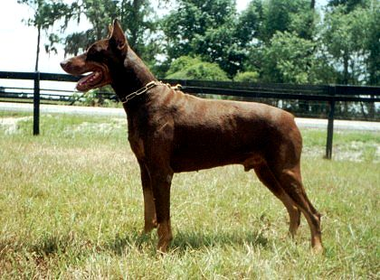
Arrk von Asgard
Bred, trained, handled, & titled/certified by his owner Linda M. Werlein, “von Asgard” Working Dog Kennels, Myakka City, FL – www.VonAsgard.com

A Lifetime of Accomplishment
SchH I --- H.I.T. - Tracking & H.I.T. - SchH I
SchH II – High In Trial (H.I.T.) - Tracking & Protection
1995 ----- UDC Nationals SchH II Vise-Champion
SchH III - H.I.T. & H.I.T.-Tracking, Obedience & Protection
1995 ----- 4th. Highest Scoring SchH III Dobermann in North America
1995 ----- AWDF Breed Team Championship - Dobermann Team SchH III
1996 ----- ARV Schutzhund Protection Tournament - Champion (99 Points)
1997 ----- AWDF Breed Team Championship - Dobermann Team SchH III
PD K-9 -- Service Dog Association – Patrol Duty K-9 Certification
1998 ----- Asgard Security Patrol – Working & Insured Police Work K-9
2000 ----- K-9 Pro Sports 'Tough Dog' (Police Type) Tournament (Professional Division) – Arrk was still competing at 9 1/2 Years of Age!

